# https://upload.wikimedia.org/wikipedia/en/f/f1/Capital_University%2C_Jharkhand_logo.png

# CAPITAL UNIVERSITY - KODERMA

OPTICAL COMMUNICATION ASSIGNMENT

Name : Arshad Nazir

Electrical and Electronics Engineering

Signature:

Date :

1.Explain optical fibre link transmission and explain the different components

Unlike copper wire-based transmission where the transmission entirely depends on electrical signals passing through the cable, fiber optics transmission involves the transmission of signals in the form of light from one point to the other. Furthermore, a fiber optic communication network consists of transmitting and receiving circuitry, a light source, and detector devices like the ones shown in the figure.

When the input data, in the form of electrical signals, is given to the transmitter circuitry, it converts them into a light signal with the help of a light source. This source is of LED whose amplitude, frequency, and phases must remain stable and free from fluctuation in order to have efficient transmission. The light beam from the source is carried by a fiber optic cable to the destination circuitry wherein the information is transmitted back to the electrical signal by a receiver circuit.

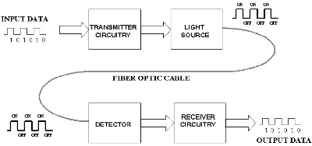

The Receiver circuit consists of a photodetector along with an appropriate electronic circuit, which is capable of measuring the magnitude, frequency, and phase of the optic field. This type of communication uses the wavelengths near the [infrared band](https://www.elprocus.com/communication-using-infrared-technology/) that is just above the visible range. Both LED and Laser can be used as light sources based on the application.

There are three main basic elements of a fiber optic communication system. They are

1. Compact Light Source
2. Low loss Optical Fiber
3. Photo Detector

Accessories like connectors, switches, couplers, multiplexing devices, amplifiers, and splices are also essential elements in this communication system.

Compact Light Source

Depending on the applications like local area networks and long-haul communication systems, the light source requirements vary. The requirements of the sources include power, speed, spectral linewidth, noise, ruggedness, cost, temperature, and so on. Two components are used as light sources: [light-emitting diodes](https://www.elprocus.com/mains-operated-led/)(LEDs) and laser diodes.

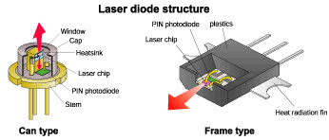

The light-emitting diodes are used for short distances and low data rate applications due to their low bandwidth and power capabilities. Two such LED structures include Surface and Edge Emitting Systems. The surface-emitting diodes are simple in design and are reliable, but due to their broader line width and modulation frequency limitation edge-emitting diodes are mostly used. Edge emitting diodes have high power and narrower linewidth capabilities.

#### Low Loss Optical Fiber

Optical fiber is a cable, which is also known as a cylindrical dielectric waveguide made of low-loss material. Optical fiber also considers the parameters like the environment in which it is operating, the tensile strength, durability, and rigidity. The Fiber optic cable is made of high-quality extruded glass (si) or plastic, and it is flexible. The diameter of the fiber optic cable is in between 0.25 to 0.5mm (slightly thicker than a human hair).

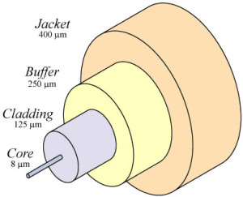

#### Photo Detectors

The purpose of photodetectors is to convert the light signal back to an electrical signal. Two types of[photodetectors](https://www.elprocus.com/phototransistor-basics-circuit-diagram-advantages-applications/) are mainly used for optical receivers in optical communication systems: PN photodiode and avalanche photodiode. Depending on the application’s wavelengths, the material composition of these devices vary. These materials include silicon, germanium, InGaAs, etc.

2. Explain the advantages of optical communication technology

### Advantages of Optical Fibber

Greater bandwidth & faster speed—Optical fibre cable supports extremely high bandwidth and speed. The large amount of information that can be transmitted per unit of optical fibre cable is its most significant advantage.

**Cheap**—Long, continuous miles of optical fibre cable can be made cheaper than equivalent lengths of copper wire. With numerous vendors swarm to compete for the market share, optical cable price would sure to drop.

**Thinner and light-weighted**—Optical fibre is thinner, and can be drawn to smaller diameters than copper wire. They are of smaller size and light weight than a comparable copper wire cable, offering a better fit for places where space is a concern.

**Higher carrying capacity**—Because optical fibres are much thinner than copper wires, more fibres can be bundled into a given-diameter cable. This allows more phone lines to go over the same cable or more channels to come through the cable into your cable TV box.

**Less signal degradation**—The loss of signal in optical fibre is less than that in copper wire.

**Light signals**—Unlike electrical signals transmitted in copper wires, light signals from one fibre do not interfere with those of other fibres in the same fibre cable. This means clearer phone conversations or TV reception.

**Long lifespan**—Optical fibres usually have a longer life cycle for over 100 years.

3.Write a note on step index fibre

For an [optical fibre](https://en.wikipedia.org/wiki/Optical_fiber), a step-index profile is a [refractive index](https://en.wikipedia.org/wiki/Refractive_index) profile characterized by a uniform refractive index within the [core](https://en.wikipedia.org/wiki/Fiber_optics#Principle_of_operation) and a sharp decrease in refractive index at the core-[cladding](https://en.wikipedia.org/wiki/Cladding_(fiber_optics)) [interface](https://en.wiktionary.org/wiki/interface) so that the cladding is of a lower refractive index. The step-index profile corresponds to a [power-law index profile](https://en.wikipedia.org/wiki/Power-law_index_profile) with the profile parameter approaching infinity. The step-index profile is used in most [single-mode fibres](https://en.wikipedia.org/wiki/Single-mode_fiber) and some [multimode fibres](https://en.wikipedia.org/wiki/Multimode_fiber)

A step-index fibre is characterized by the core and cladding refractive indices *n1* and *n2* and the core and cladding radii a and b. Examples of standard core and cladding diameters 2a/2b are 8/125, 50/125, 62.5/125, 85/125, or 100/140 (units of µm).

The fractional refractive-index change {\displaystyle \triangle \,={\frac {n_{1}-n_{2}}{n_{1}}}\ll \ 1}. The value of n1 is typically between 1.44 and 1.46, and {\displaystyle \triangle } is typically between 0.001 and 0.02.

Step-index optical fibre is generally made by [doping](https://en.wikipedia.org/wiki/Doping_(semiconductor)) high-purity fused [silica glass](https://en.wikipedia.org/wiki/Fused_quartz) (SiO2) with different concentrations of materials like titanium, germanium, or boron.

4.Explain the ray propagation into and down an optical fibre cable.

The concept of light propagation, the transmission of light along an optical fibre, can be described by two theories. According to the first theory, light is described as a simple ray. This theory is the ray theory, or geometrical optics, approach. The advantage of the ray approach is that you get a clearer picture of the propagation of light along a fibre.

The ray theory is used to approximate the light acceptance and guiding properties of optical fibres. According to the second theory, light is described as an electromagnetic wave. This theory is the mode theory, or wave representation, approach.

The mode theory describes the behaviour of light within an optical fibre. The mode theory is useful in describing the optical fibre properties of absorption, attenuation, and dispersion.

Then laser light is coupled into a fibre, the distribution of the light emerging from the other end reveals if the fibre is a multimode or single mode fibre.

Optical fibres are used widely in the medical field for diagnoses and treatment.  Optical fibres can be bundled into flexible strands, which can be inserted into blood vessels, lungs and other parts of the body.  An Endoscope is a medical tool carrying two bundles of optic fibres inside one long tube.

One bundle directs light at the tissue being tested, while the other bundle carries light reflected from the tissue, producing a detailed image.  Endoscopes can be designed to look at regions of the human body, such as the knees, or other joints in the body.

5.Compare the optical link with that of the satellite link

| o. | Satellite Communication | Optical Communication |
| --- | --- | --- |
| 1. | Satellite communication uses electromagnetic waves as a medium for propagation. | Optical communication uses the light rays as a medium of propagation. |
|  | In satellite communication, satellites as a relay station are used for communication. | In optical communication, communication happens via optical fibre. |
| 3. | In satellite communication, for transmission and reception of signals special type of antennas are needed. | In optical communication, no special antennas are needed for communication. |
| 4. | Air is the transmission medium in satellite communication. | While in optical communication, fibre is the transmission medium. |
| 5. | Each transponder in satellite communication supports a bandwidth of 36 MHz and hold 12 channels simultaneously. | Optical fibre supports a bandwidth of very large range and one cable combines many fibres. |
| 6. | Satellite communication is convenient and effective for very long-distance communication. | For point-to-point short distance communication, optical communication is appropriate and effective. |
| 7. | Cost of installation is very expensive. | Cost of installation is very less as compared to satellite communication. |

6 Explain the differences between meridional and skew rays. In detail discuss about the skew rays

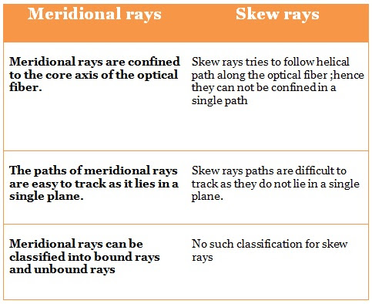

Skew rays are rays that travel through an optical fibre without passing through its axis.

Skew rays are those rays which follow helical path but they are not confined to a single plane. Skew rays are not confined to a particular plane so they cannot be tracked easily. Analysing the meridional rays is sufficient for the purpose of result, rather than skew rays, because skew rays lead to greater power loss.

Skew rays propagate without passing through the centre axis of the fibre. The acceptance angle for skew rays is larger than the acceptance angle of meridional rays.

Skew rays are often used in the calculation of light acceptance in an optical fibre. The addition of skew rays increases the amount of light capacity of a fibre. In large NA fibres, the increase may be significant.

7. List the factors that cause intrinsic joint losses in a fibre.

Internal reasons of fibre optic loss caused by the fibre optic itself, which is also usually called intrinsic attenuation. There are two main causes of intrinsic attenuation. One is light absorption and the other one is scattering.

**Light absorption** is a major cause of losses in optical fibre during optical transmission. The light is absorbed in the fibre by the materials of fibre optic. Thus, light absorption in optical fibre is also known as material absorption. Actually, the light power is absorbed and transferred into other forms of energy like heat, due to molecular resonance and wavelength impurities.

Atomic structure is in any pure material and they absorb selective wavelengths of radiation. It is impossible to manufacture materials that are total pure. Thus, fibre optic manufacturers choose to dope germanium and other materials with pure silica to optimize the fibre optic core performance.

8. What do you mean by pulse broadening? Explain its effect on information carrying capacity of a fibre

Pulse broadening: An increase in [pulse duration](https://www.its.bldrdoc.gov/fs-1037/dir-029/_4250.htm). *Note:* Pulse broadening may be specified by the [impulse response](https://www.its.bldrdoc.gov/fs-1037/dir-018/_2686.htm), the [root-mean-square pulse broadening](https://www.its.bldrdoc.gov/fs-1037/dir-031/_4634.htm), or the full-duration-at-half-maximum pulse broadening.

In multi-mode fibres, several modes propagate with varying velocities. These modes can be understood as different paths the light can take through the fibre and will be described in more detail in the chapter on optical fibres.

As a consequence of dispersion, pulse broadening occurs possibly leading to an overlap of the pulses. The recipient of the signal is not able to distinguish between two adjacent pulses or one great pulse if the dispersion effect is too pronounced. Especially POFs show large [modal dispersion](https://www.sciencedirect.com/topics/materials-science/modal-dispersion) that usually represents the strongest limitation for optical transmission.

Even in single-mode fibres, where modal dispersion cannot occur, dispersion effects are still visible due to the fact that the light shows a spectral width which is at least in the same order of magnitude as the modulation bandwidth. Consequently, the light components will arrive at the receiver with varying time delays which also leads to pulse broadening or signal degradation.

The phenomenon of chromatic dispersion is also visible in lenses leading to the fact that white light will be partly spread into its components due to different refraction of the air-lens interfaces, well known as chromatic aberration. The two effects of modal dispersion, which can be controlled by the refractive–index profile of the fibre, and the wavelength-dependent chromatic dispersion mainly determine the bandwidth of the optical [waveguide](https://www.sciencedirect.com/topics/materials-science/waveguide).

9. Define signal distortion? How does Signal distortion in single mode fibres?

The [bandwidth](https://www.britannica.com/technology/bandwidth) of an optical fibre is limited by a phenomenon known as multimode dispersion, which is described as follows. Different reflection [angles](https://www.britannica.com/science/angle-of-reflection) within the fibre core create different [propagation](https://www.merriam-webster.com/dictionary/propagation) paths for the light rays. Rays that travel nearest to the axis of the core [propagate](https://www.merriam-webster.com/dictionary/propagate) by what is called the zeroth order mode; other light rays propagate by higher-order modes.

It is the simultaneous presence of many modes of propagation within a single fibre that creates multimode dispersion. Multimode dispersion causes a signal of uniform transmitted intensity to arrive at the far end of the fibre in a complicated spatial “interference pattern,” and this pattern in turn can translate into pulse “spreading” or “smearing” and inter symbol interference at the optoelectronic receiver output.

Pulse spreading worsens in longer fibres.

(1) Intrinsic loss in the fibre material. (2) Scattering due to micro irregularities inside the fibre. (3) Micro-bending losses due to micro-deformation of the fibre. (4) Bending or radiation losses on the fibre.

10. Describe the linear scattering losses in optical fibers

Scattering losses in glass arise from microscopic variations in the material density, from compositional fluctuations and from structural inhomogeneties or defects occurring during fiber manufacture.

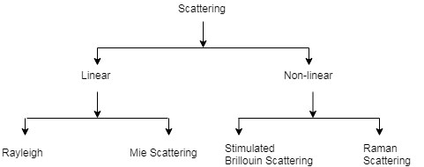

**I. Linear Scattering mechanism:**

* It causes the transfer of some or all of the optical power contained within one propagating mode to be transferred linearly into a different mode.
* This process tends to a result in attenuation of the transmitted light as the transfer may be to a leaky or radiation mode which does not continue to propagate within the fibre core, but is radiated from the fibre. With all linear process there is no change of frequency on scattering.
* Linear scattering may be categorized as:

a.Rayleigh scattering

b. Mie scattering

**a. Rayleigh scattering:**

* For glass fibers the foremost type of scattering is Rayleigh scattering. With this process, atoms or other particles within the fiber absorb the light signal and instantly re-emits the light in another direction.
* In this way Rayleigh scattering appears very much like absorption but it absorbs and redirects the light so quickly that is considered scattering.

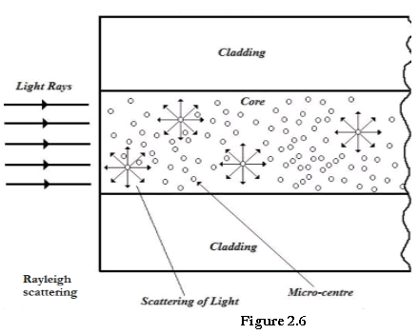

* The Rayleigh scattering formula is given by:

γR=8π33λ4n8p2βckTFγR=8π33λ4n8p2βckTF

Where γRγR is Rayleigh scattering coefficient.

λ is optical wavelength and η is the refractive index of the medium

p is average photoelastic coefficient

βcβc is isothermal compressibility at a fictive temperature TFTF

k is Boltzmann’s constant

**b. Mie scattering:**

* Imperfections caused due to inhomogeneities at the core- cladding interface which causes scattering of light.
* The scattering created by such inhomogeneities is mainly in the forward direction and is called Mie scattering.
* It can be reduced by removing imperfections of glass at the time of manufacture, increasing the relative refractive index of the core and the cladding.

11.How waveguide dispersion affects the performance of the transmission in an optical fiber?

In [optical fibers](https://www.sciencedirect.com/topics/engineering/optical-fibers), the signal travels partially in the core and partially in the cladding, and the total mode [field diameter](https://www.sciencedirect.com/topics/engineering/field-diameter) changes with wavelength. Since the refractive index is different in the core than in the cladding, a change in mode field diameter also results in a change in average dispersion index and, therefore, [signal velocity](https://www.sciencedirect.com/topics/computer-science/velocity-signal). The ratio of velocity change to wavelength change due to this effect is known as waveguide dispersion.

As with modal dispersion, chromatic dispersion is a [linear function](https://www.sciencedirect.com/topics/computer-science/linear-function) of transmission system length. The units of chromatic dispersion are [picoseconds](https://www.sciencedirect.com/topics/engineering/picosecond) per nanometer-kilometer; that is, for a 1-nm, free-space wavelength change, this gives the number of picoseconds of delay change per kilometre of [fiber length](https://www.sciencedirect.com/topics/engineering/fibre-length" \o "Learn more about Fibre Length from ScienceDirect's AI-generated Topic Pages).

Standard fiber exhibits zero chromatic dispersion near 1310 nm (because the slopes of waveguide and material dispersion components are equal in magnitude and opposite in direction at that wavelength).

In cases where it is important to have low dispersion at 1550 nm, the null point can be shifted upward by altering the fiber-doping profile and/or using several layers of cladding.  gives one example of a doping profile for dispersion-shifted fiber. a typical chromatic [dispersion curve](https://www.sciencedirect.com/topics/engineering/dispersion-curve) for both non-dispersion-shifted and dispersion-shifted single-mode fibers.

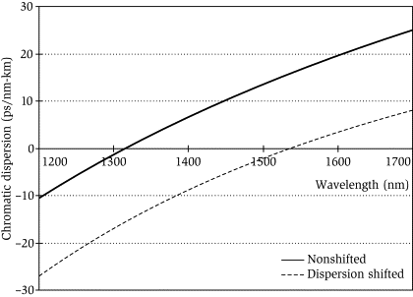

Typical commercial specifications for chromatic dispersion are 2.8 to 3.2 ps/nm-km from 1285- to 1330-nm wavelength and 17 to 18 ps/nm-km near 1550 nm for no shifted fibers.

Dispersion is very important in communications circuits because the optical sources used do not transmit on a single wavelength.

#### WAVEGUIDE DISPERSION

Waveguide dispersion is only important in single mode fibers. It is caused by the fact that some light travels in the fiber cladding compared to most light travels in the fiber core. It is shown as the 3rd illustration in the first picture.

Since fiber cladding has lower refractive index than fiber core, light ray that travels in the cladding travels faster than that in the core. Waveguide dispersion is also a type of chromatic dispersion.  It is a function of fiber core size, V-number, wavelength and light source linewidth.

[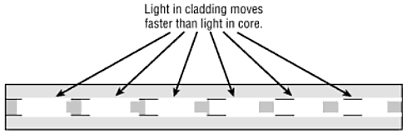](https://s3-us-west-1.amazonaws.com/foscoshopify/graphics/uploads/2009/02/waveguidedispersion.gif)

While the difference in refractive indices of single mode fiber core and cladding are minuscule, they can still become a factor over greater distances. It can also combine with material dispersion to create a nightmare in single mode chromatic dispersion.

Various tweaks in the design of single mode fiber can be used to overcome waveguide dispersion, and manufacturers are constantly refining their processes to reduce its effects.

12. What is dispersion in fibers? What are the causes and types of fiber dispersion loss.

Dispersion is the spreading out of a light pulse in time as it propagates down the fiber. Dispersion in optical fiber includes model dispersion, material dispersion and waveguide dispersion. Each type is discussed in detail below.

[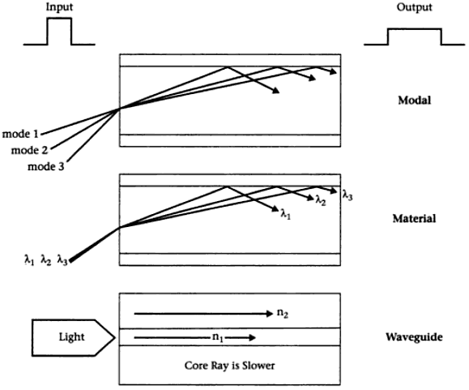](https://s3-us-west-1.amazonaws.com/foscoshopify/graphics/uploads/2009/02/opticalfiberdispersion.gif)

#### MODEL DISPERSION IN MULTIMODE FIBERS

Multimode fibers can guide many different light modes since they have much larger core size. This is shown as the 1st illustration in the picture above. Each mode enters the fiber at a different angle and thus travels at different paths in the fiber.

Since each mode ray travels a different distance as it propagates, the ray arrive at different times at the fiber output. So the light pulse spreads out in time which can cause signal overlapping so seriously that you cannot distinguish them any more.

Model dispersion is not a problem in single mode fibers since there is only one mode that can travel in the fiber.

#### MATERIAL DISPERSION

Material dispersion is the result of the finite linewidth of the light source and the dependence of refractive index of the material on wavelength.  It is shown as the 2nd illustration in the first picture.

Material dispersion is a type of chromatic dispersion. Chromatic dispersion is the pulse spreading that arises because the velocity of light through a fiber depends on its wavelength.

The following picture shows the refractive index versus wavelength for a typical fused silica glass.

[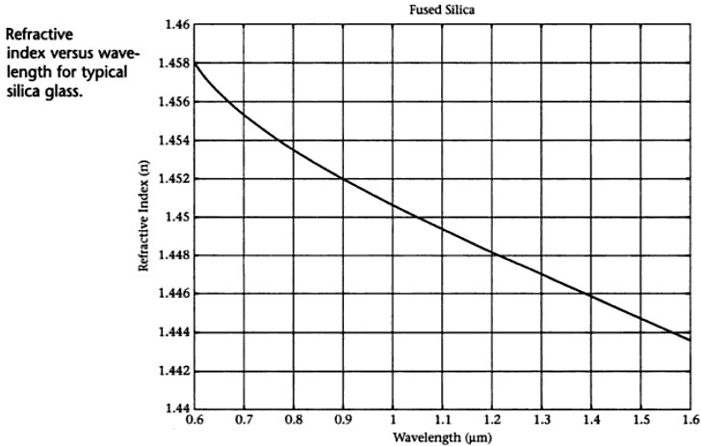](https://s3-us-west-1.amazonaws.com/foscoshopify/graphics/uploads/2009/02/refractiveindexversuswavelengthinsilicaglassfiber.gif)

#### WAVEGUIDE DISPERSION

Waveguide dispersion is only important in single mode fibers. It is caused by the fact that some light travels in the fiber cladding compared to most light travels in the fiber core. It is shown as the 3rd illustration in the first picture.

Since fiber cladding has lower refractive index than fiber core, light ray that travels in the cladding travels faster than that in the core. Waveguide dispersion is also a type of chromatic dispersion.  It is a function of fiber core size, V-number, wavelength and light source linewidth.

[](https://s3-us-west-1.amazonaws.com/foscoshopify/graphics/uploads/2009/02/waveguidedispersion.gif)

While the difference in refractive indices of single mode fiber core and cladding are minuscule, they can still become a factor over greater distances. It can also combine with material dispersion to create a nightmare in single mode chromatic dispersion.

Various tweaks in the design of single mode fiber can be used to overcome waveguide dispersion, and manufacturers are constantly refining their processes to reduce its effects.

13 Explain (a) intra modal and (b) inter modal dispersion

**Dispersion**:

* Dispersion is the broadening of actual time-width of the pulse due to material properties and imperfections.
* As pulse travels down the fiber, dispersion causes pulse spreading. This limits the distance travelled by the pulse and the bit rate of data on optical fiber.
* In a fiber three distinct types of distortion are observed:

**1. Intramodal dispersion:**

* Pulse broadening within a single mode is called as intramodal dispersion or chromatic dispersion.
* Since this phenomenon is wavelength dependent and group velocity is a function of wavelength, it is also called as group velocity dispersion (GVD).
* The two main causes of intramodal dispersion are as follows:

a. Material dispersion:

* + It is the pulse spreading due to the dispersive properties of material.
  + It arises from variation of refractive index of the core material as a function of wavelength.
  + Material dispersion is a property of glass as a material and will always exist irrespective of the structure of the fiber.

b. Waveguide dispersion:

* + It occurs because a single mode fiber confines only about 80% of the optical power to the core.
  + Dispersion thus arises since the 20% light propagating in the cladding travels faster than light confined to the core.
  + The amount of waveguide dispersion depends on the structure of the fiber and can be varied by altering the parameters such as NA, core radius etc.

**2. Intermodal dispersion:**

* + Dispersion caused by multipath propagation of light energy is referred to as intermodal dispersion.
  + Signal degradation occurs due to different values of group delay for each individual mode at a single frequency.
  + In digital transmission, we use light pulse to transmit bit 1 and no pulse for bit 0. When the light pulse enters fiber it is breakdown into small pulses carried by individual modes. At the output individual pulses are recombined and since they are overlapped receiver sees a long pulse causing pulse broadening.

14. Explain how the bandwidth of an optical fiber is affected

The bandwidth of optical fiber is affected by :

1 materials used in optical fiber.

2. Intramodal dispersion:

* Pulse broadening within a single mode is called as intramodal dispersion or chromatic dispersion.
* Since this phenomenon is wavelength dependent and group velocity is a function of wavelength, it is also called as group velocity dispersion (GVD).
* The two main causes of intramodal dispersion are as follows:

a. Material dispersion:

* + It is the pulse spreading due to the dispersive properties of material.
  + It arises from variation of refractive index of the core material as a function of wavelength.
  + Material dispersion is a property of glass as a material and will always exist irrespective of the structure of the fiber.

b. Waveguide dispersion:

* + It occurs because a single mode fiber confines only about 80% of the optical power to the core.
  + Dispersion thus arises since the 20% light propagating in the cladding travels faster than light confined to the core.
  + The amount of waveguide dispersion depends on the structure of the fiber and can be varied by altering the parameters such as NA, core radius etc.

3. Intermodal dispersion:

* + Dispersion caused by multipath propagation of light energy is referred to as intermodal dispersion.
  + Signal degradation occurs due to different values of group delay for each individual mode at a single frequency.
  + In digital transmission, we use light pulse to transmit bit 1 and no pulse for bit 0. When the light pulse enters fiber it is breakdown into small pulses carried by individual modes. At the output individual pulses are recombined and since they are overlapped receiver sees a long pulse causing pulse broadening.

4.Pulse broadening in optical fibers

15. Explain how a signal distortion occurs in Optical wave guides

The major reason for signal distortion within optical waveguide is dispersion. Dispersion of the transmitted optical signal causes distortion for both digital analog transmissions along the optical fibers. While considering the main implementation of the optical fiber transmission that includes some form of digital modulation, the dispersion mechanism inside the fiber causes broadening of the transmitted light pulses as they travel along the channel. The major purpose for the broadening of the signal pulse is inter-symbol interference (ISI).

Dispersion is classified into

1.      Intermodal

2.      Intramodal (chromatic)

* Material dispersion
* Waveguide dispersion

The reason for the inter modal dispersion is the number of modes inside the fiber. As the number modes passes by the fiber, the various modes travel different distances, so in which they reach at the destination at various times.

The pulse at the output is depends upon the transmission times of the slowest and fastest modes. For a single mode fiber the intermodal dispersion is absent and for the step index multimode fiber inter modal dispersion effect is extremely high. To overcome this we use multimode graded index fibers.

Intra modal dispersion or chromatic dispersion might occur in all kinds of optical fibers and results from the finite spectral width of optical source, because optical sources does not emit only a single frequency, but a band of frequencies, then there might be propagation delay differences among the different spectral element of the transmitted signal.

This causes broadening of every transmitted mode and therefore intra modal dispersion. The delay differences might be caused through dispersive properties of the material (material dispersion) and also guidance effects inside the fiber structure (waveguide dispersion).

Pulse broadening because of material dispersion results from the different group velocities of several spectral elements launched into the fiber from the optical source. It occurs when the phase velocity of plane wave propagating in the dielectric medium varies non-linearly along with wavelength, and a material is said to exhibit material dispersion while the second order differential of the refractive index along with respect to wavelength is not zero,

Ie, d2n/dλ2 ≠ 0

The variation of material dispersion along with wavelength is display below:

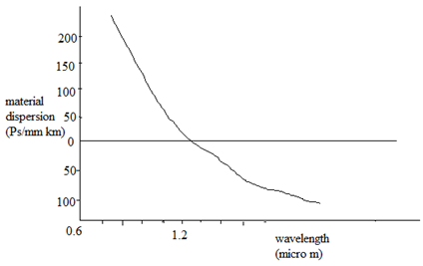

It might be observed that, the material dispersion tends to zero in the longer wavelength region around 1.3 µm for pure silica as display above. It can also be decreased through injection laser along with a narrow spectral width rather than an LED as the optical source.

The wave guiding of the fiber might also cause intra modal dispersion. This results from the variations in group velocity along with wavelength for a particular mode. Considering the ray theory approach it equivalent to the angle among the ray and the fiber axis varying along with wavelength that subsequently leads to variations in the transmission times for the rays, and hence dispersion. For a single mode fiber, whose propagation constant β, the fiber exhibit waveguide dispersion when,

d2β/dλ2 ≠0

Therefore these type of dispersion   cause signal distortion.

16. Write short note on 1) Fiber connectors 2) Splices and couplers.

Fiber connectors

An **optical fiber connector** joins [optical fibers](https://en.wikipedia.org/wiki/Optical_fiber), and enables quicker connection and disconnection than [splicing](https://en.wikipedia.org/wiki/Mechanical_splice). The connectors mechanically couple and align the cores of fibers so light can pass. Better connectors lose very little light due to reflection or misalignment of the fibers. In all, about 100 different types of fiber optic connectors have been introduced to the market.[[1]](https://en.wikipedia.org/wiki/Optical_fiber_connector#cite_note-FOAConnID-1)

Optical fiber connectors are used to join optical fibers where a connect/disconnect capability is required. Due to the polishing and tuning procedures that may be incorporated into optical connector manufacturing, connectors are often assembled onto optical fiber in a supplier's manufacturing facility. However, the assembly and polishing operations involved can be performed in the field, for example, to [terminate](https://en.wikipedia.org/wiki/Fiber_cable_termination) long runs at a [patch panel](https://en.wikipedia.org/wiki/Patch_panel).

Optical fiber connectors are used in [telephone exchanges](https://en.wikipedia.org/wiki/Telephone_exchange), for [customer premises wiring](https://en.wikipedia.org/wiki/Customer_premises_wiring), and in [outside plant](https://en.wikipedia.org/wiki/Outside_plant) applications to connect equipment and [fiber-optic cables](https://en.wikipedia.org/wiki/Fiber-optic_cable" \o "Fiber-optic cable), or to cross-connect cables.

Most optical fiber connectors are spring-loaded, so the fiber faces are pressed together when the connectors are mated. The resulting glass-to-glass or plastic-to-plastic contact eliminates signal losses that would be caused by an air gap between the joined fibers.

Splices and couplers

There are two different ways to join two optical fibers: splices or connectors. Splices are permanent joints, while connectors allow the two fibers to be disconnected at the joint. There are obvious advantages with connectors, allowing for changes in network connections or accessing the network for testing. Splices, however, offer lower optical loss at the joint and higher reliability-an advantage for long-distance networks installed outdoors. Sometimes the decision whether to use splices or connectors is made based on less obvious factors.

There are other subtle differences between connectors and splices. Take size, for instance. A patch panel of connectors takes up a lot of space, especially when you consider the extra space needed to get a human hand into the patch panel to grab a connector, connect or disconnect it.

Even the so-called “small-form factor” connectors take up a lot of space on a panel. The same number of splices will fit in a small, thin splice tray that takes only a fraction of the space required by the same number of connectors.

Splices have less back reflection, an important specification for single-mode networks, especially where high-speed networks are used on short campus or building backbones. But splices may adversely affect the bandwidth of multimode fiber by mode mixing at the splice.

Some splices can be much less expensive if you are doing a lot of fiber joints. This is another big advantage for long distance networks where cables contain many fibers and require splicing every few kilometres. A fusion splice uses a machine to weld fibers together in an electric arc, making the lowest possible loss joint.

17. Explain the working of a light emitting diode

A light-emitting diode (LED) is a [semiconductor](https://en.wikipedia.org/wiki/Semiconductor) [light source](https://en.wikipedia.org/wiki/Light_source) that emits light when [current](https://en.wikipedia.org/wiki/Electric_current) flows through it. [Electrons](https://en.wikipedia.org/wiki/Electron) in the semiconductor recombine with [electron holes](https://en.wikipedia.org/wiki/Electron_hole), releasing energy in the form of [photons](https://en.wikipedia.org/wiki/Photon). The colour of the light (corresponding to the energy of the photons) is determined by the energy required for electrons to cross the [band gap](https://en.wikipedia.org/wiki/Band_gap) of the semiconductor.

White light is obtained by using multiple semiconductors or a layer of light-emitting [phosphor](https://en.wikipedia.org/wiki/Phosphor) on the semiconductor device.

Appearing as practical electronic components in 1962, the earliest LEDs emitted low-intensity [infrared](https://en.wikipedia.org/wiki/Infrared) (IR) light.[[7]](https://en.wikipedia.org/wiki/Light-emitting_diode#cite_note-FirstPracticalLED-7) Infrared LEDs are used in [remote-control](https://en.wikipedia.org/wiki/Remote-control) circuits, such as those used with a wide variety of consumer electronics. The first visible-light LEDs were of low intensity and limited to red. Early LEDs were often used as indicator lamps, replacing small [incandescent bulbs](https://en.wikipedia.org/wiki/Incandescent_light_bulb), and in [seven-segment displays](https://en.wikipedia.org/wiki/Seven-segment_display).

Recent developments have produced LEDs available in [visible](https://en.wikipedia.org/wiki/Visible_spectrum), [ultraviolet](https://en.wikipedia.org/wiki/Ultraviolet) (UV), and infrared wavelengths, with high, low, or intermediate light output, for instance white LEDs suitable for room and outdoor area lighting. LEDs have also given rise to new types of displays and sensors, while their high switching rates are useful in advanced communications technology with applications as diverse as [aviation lighting](https://en.wikipedia.org/wiki/Navigation_light#Aviation_navigation_lights), [fairy lights](https://en.wikipedia.org/wiki/Fairy_lights), [automotive headlamps](https://en.wikipedia.org/wiki/Automotive_lighting#Light-emitting_diodes_(LED)), advertising, [general lighting](https://en.wikipedia.org/wiki/Lighting), [traffic signals](https://en.wikipedia.org/wiki/Traffic_signal), camera flashes, [lighted wallpaper](https://en.wikipedia.org/wiki/LED_wallpaper), [horticultural grow lights](https://en.wikipedia.org/wiki/Grow_light), and medical devices.

18. What are the possible noise sources that contribute the photodetector noise.

Photo detector noise is that undesired disturbance masks the signal in communication system.

Sources of photodetection noise. Major noise sources in a photodiode can be categorized as thermal noise, shot noise, and dark current noise. Because of the random nature of the noises, the best way to specify them is to use their statistical values, such as spectral density, power, and bandwidth.

When a photodetector does not get any input light, it nevertheless produces some noise output with a certain average power, which is proportional to the square of the r.m.s. voltage or current amplitude.

19 Write notes on fiber splices and connectors.

Splices and couplers

There are two different ways to join two optical fibers: splices or connectors. Splices are permanent joints, while connectors allow the two fibers to be disconnected at the joint. There are obvious advantages with connectors, allowing for changes in network connections or accessing the network for testing. Splices, however, offer lower optical loss at the joint and higher reliability-an advantage for long-distance networks installed outdoors. Sometimes the decision whether to use splices or connectors is made based on less obvious factors.

There are other subtle differences between connectors and splices. Take size, for instance. A patch panel of connectors takes up a lot of space, especially when you consider the extra space needed to get a human hand into the patch panel to grab a connector, connect or disconnect it.

Even the so-called “small-form factor” connectors take up a lot of space on a panel. The same number of splices will fit in a small, thin splice tray that takes only a fraction of the space required by the same number of connectors.

Splices have less back reflection, an important specification for single-mode networks, especially where high-speed networks are used on short campus or building backbones. But splices may adversely affect the bandwidth of multimode fiber by mode mixing at the splice.

Some splices can be much less expensive if you are doing a lot of fiber joints. This is another big advantage for long distance networks where cables contain many fibers and require splicing every few kilometres. A fusion splice uses a machine to weld fibers together in an electric arc, making the lowest possible loss joint.

Fiber connectors

An **optical fiber connector** joins [optical fibers](https://en.wikipedia.org/wiki/Optical_fiber), and enables quicker connection and disconnection than [splicing](https://en.wikipedia.org/wiki/Mechanical_splice). The connectors mechanically couple and align the cores of fibers so light can pass. Better connectors lose very little light due to reflection or misalignment of the fibers. In all, about 100 different types of fiber optic connectors have been introduced to the market.[[1]](https://en.wikipedia.org/wiki/Optical_fiber_connector#cite_note-FOAConnID-1)

Optical fiber connectors are used to join optical fibers where a connect/disconnect capability is required. Due to the polishing and tuning procedures that may be incorporated into optical connector manufacturing, connectors are often assembled onto optical fiber in a supplier's manufacturing facility.

However, the assembly and polishing operations involved can be performed in the field, for example, to [terminate](https://en.wikipedia.org/wiki/Fiber_cable_termination) long runs at a [patch panel](https://en.wikipedia.org/wiki/Patch_panel).

Optical fiber connectors are used in [telephone exchanges](https://en.wikipedia.org/wiki/Telephone_exchange), for [customer premises wiring](https://en.wikipedia.org/wiki/Customer_premises_wiring), and in [outside plant](https://en.wikipedia.org/wiki/Outside_plant) applications to connect equipment and [fiber-optic cables](https://en.wikipedia.org/wiki/Fiber-optic_cable" \o "Fiber-optic cable), or to cross-connect cables.

Most optical fiber connectors are spring-loaded, so the fiber faces are pressed together when the connectors are mated. The resulting glass-to-glass or plastic-to-plastic contact eliminates signal losses that would be caused by an air gap between the joined fibers.

20. Explain any two types of pre amplifiers used in a receiver

 Preamplifier, also known as a preamp, is an [electronic amplifier](https://en.wikipedia.org/wiki/Electronic_amplifier) that converts a weak electrical [signal](https://en.wikipedia.org/wiki/Signalling_(telecommunication)) into an output signal strong enough to be noise-tolerant and strong enough for further processing, or for sending to a [power amplifier](https://en.wikipedia.org/wiki/Power_amplifier) and a [loudspeaker](https://en.wikipedia.org/wiki/Loudspeaker).

Without this, the final signal would be noisy or distorted. They are typically used to amplify signals from analog sensors such as [microphones](https://en.wikipedia.org/wiki/Microphone) and [pickups](https://en.wikipedia.org/wiki/Pickup_(guitar)). Because of this, the preamplifier is often placed close to the [sensor](https://en.wikipedia.org/wiki/Sensor) to reduce the effects of [noise](https://en.wikipedia.org/wiki/Noise_(electronics)) and [interference](https://en.wikipedia.org/wiki/Electromagnetic_interference).

An ideal preamp will be linear (have a constant [gain](https://en.wikipedia.org/wiki/Gain_(electronics)) through its operating range), have high [input impedance](https://en.wikipedia.org/wiki/Input_impedance) (requiring only a minimal amount of current to sense the input signal) and a low [output impedance](https://en.wikipedia.org/wiki/Output_impedance) (when current is drawn from the output there is minimal change in the output voltage). It is used to boost the signal strength to drive the cable to the main instrument without significantly degrading the [signal-to-noise ratio](https://en.wikipedia.org/wiki/Signal-to-noise_ratio) (SNR).

The noise performance of a preamplifier is critical. According to [Friis's formula](https://en.wikipedia.org/wiki/Friis_formulas_for_noise" \o "Friis formulas for noise), when the gain of the preamplifier is high, the SNR of the final signal is determined by the SNR of the input signal and the [noise figure](https://en.wikipedia.org/wiki/Noise_figure) of the preamplifier.

Three basic types of preamplifiers are available:

* + - * current-sensitive preamplifier
      * [parasitic-capacitance](https://en.wikipedia.org/wiki/Parasitic_capacitance) preamplifier
      * [charge-sensitive preamplifier](https://en.wikipedia.org/wiki/Charge_amplifier).